**Bayesian Interpretation of Accumulated Evidence on Invasive Treatment Strategies for Elderly Patients with Acute Coronary Syndromes**

**Analysis report**

**George CM Siontis1 & Orestis Efthimiou2**

***1*** *Department of Cardiology, Bern University Hospital, Inselspital, University of Bern, Bern, Switzerland.*

***2*** *Institute of Primary Health Care (BIHAM), University of Bern, Bern, Switzerland.*

Contents

1 Composite outcome all cause mortality and myocardial infarction 3

1.1 Frequentist meta-analysis 3

1.2 Bayesian meta-analyses 3

1.2.1 Fixed effect meta-analysis 3

1.2.2 Random effects 4

2 All-cause mortality 8

2.1 Frequentist meta-analysis 8

2.2 Bayesian analysis 8

3 Cardiovascular mortality 9

3.1 Frequentist meta-analysis 9

3.2 Bayesian analysis 9

4 Myocardial Infarction 10

4.1 Frequentist meta-analysis 10

4.2 Bayesian analysis 10

5 Urgent revascularization 11

5.1 Frequentist meta-analysis 11

5.2 Bayesian analysis 11

6 Stroke 12

6.1 Frequentist meta-analysis 12

6.2 Bayesian analysis 12

7 References 13

# Composite outcome all cause mortality and myocardial infarction

Below we provide the data extracted from the individual studies. These are the ones included in an IPD meta-analysis1 and the SENIOR_RITA trial.2 This shows the hazard ratio (HR), and lower and upper 95% Confidence Intervals of the treatment effect

Study year hr lci uci

2 ItalianElderlyACS 2012 0.97 0.57 1.66

3 AfterEighty 2016 0.64 0.45 0.90

4 MOSCA 2016 0.91 0.51 1.64

5 80+Study 2020 0.74 0.41 1.33

6 RINCAL 2021 0.73 0.44 1.22

7 MOSCA-FRAIL 2023 1.41 0.84 2.37

8 SENIOR-RITA 2024 0.97 0.83 1.13

## Frequentist meta-analysis

We perform a pairwise meta-analysis using the meta package in R.3

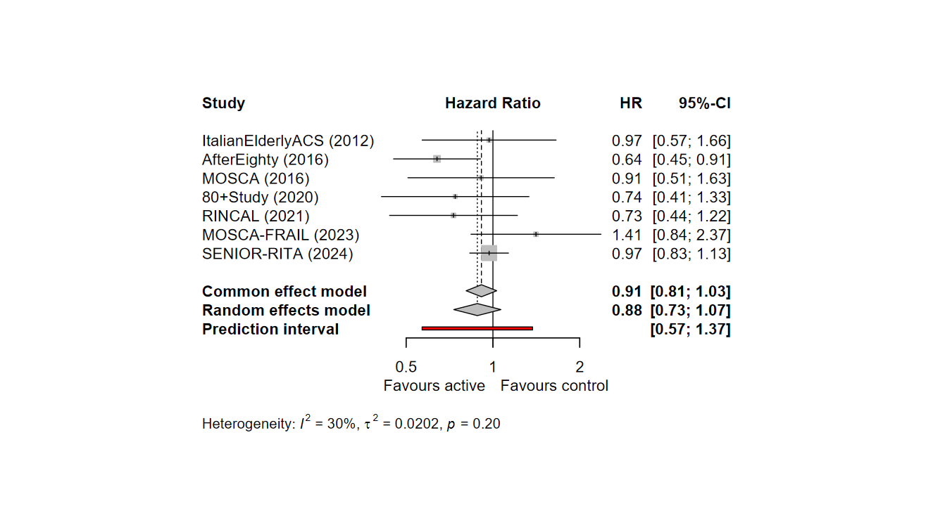

## Bayesian meta-analyses

### Fixed effect meta-analysis

We repeated the analysis, this time using a Bayesian fixed-effect model.

In the above, denotes the observed treatment effect (log-hazard ratio) observed in study and the corresponding variance. We fit the model via MCMC using R2jags in R.4 For the treatment effect we used an uninformative prior We used 6 chains, 10,000 iterations each, after an initial adaptation of 500 iterations. The posterior estimate HR= 0.91 [95% Credible Interval 0.81; 1.03], i.e. exactly matching the results from the frequentist analysis.

We ensured convergence by visually checking the posterior distribution and by checking the mixing of the chains. We also checked R-hat, which was found to be equal to 1, suggesting convergence. The effective sample size (ESS) for the HR was 59348.

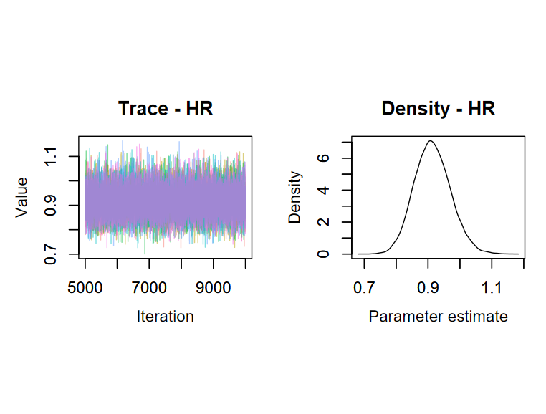

We calculated the posterior probability that the active is better than control as the percent of MCMC iterations where HR>1. This was found to be 93.1%.

Below we show a plot of the posterior distribution.

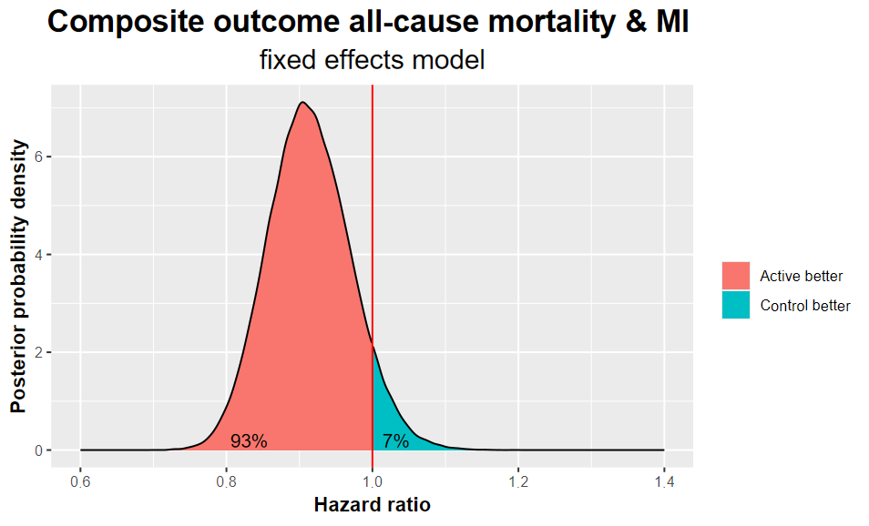

In sensitivity analyses we used different, weakly informative prior distributions for the treatment effect, i.e., and . Results were not materially different.

### Random effects

We repeated the analysis using a random effects model.

Here we used a truncated standard normal distribution for the standard deviation of random effects on the log-HR scale (“heterogeneity”). We fit the model using again 6 chains, 10,000 iterations after 500 iterations for adaptation.

The posterior estimate for HR was 0.89 [0.68; 1.14]. Heterogeneity was estimated at τ=0.18 [0.01; 0.58], with τ2= 0.033 [0.0001; 0.3360].

Below we show the plots for the assessment of convergence. R-hat was below 1.01 for all parameters. The ESS was17,425 for the HR and 2,710 for τ. Increasing the number to iterations to 30,000 per chain did not lead to materially different results.

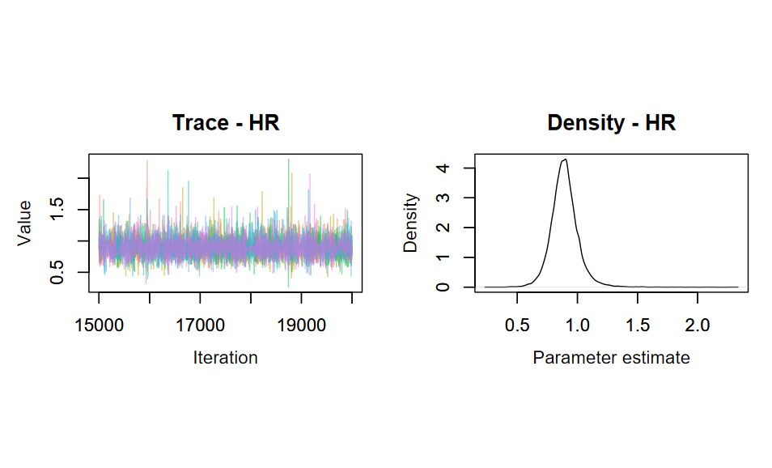

Posterior probability that the active is better than control was estimated at 86.2%.

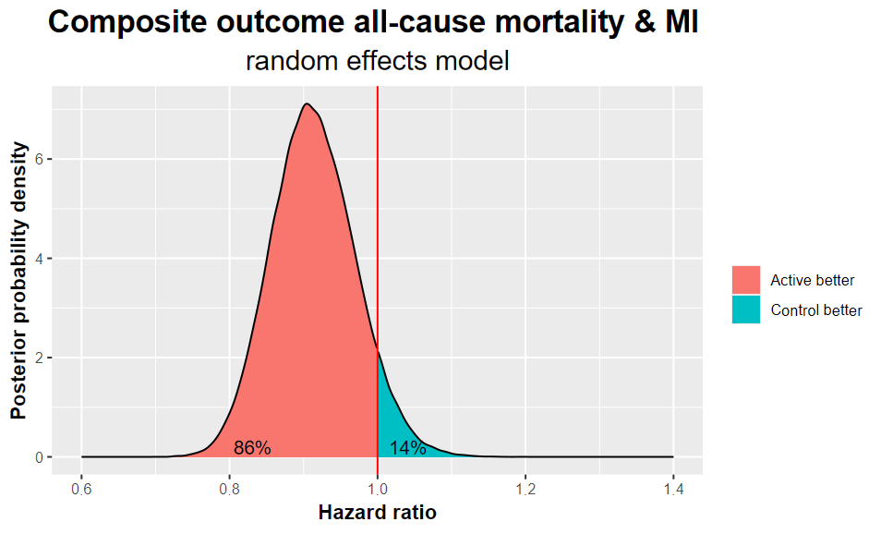

Below we combine the two graphs for fixed and random effects meta-analysis.

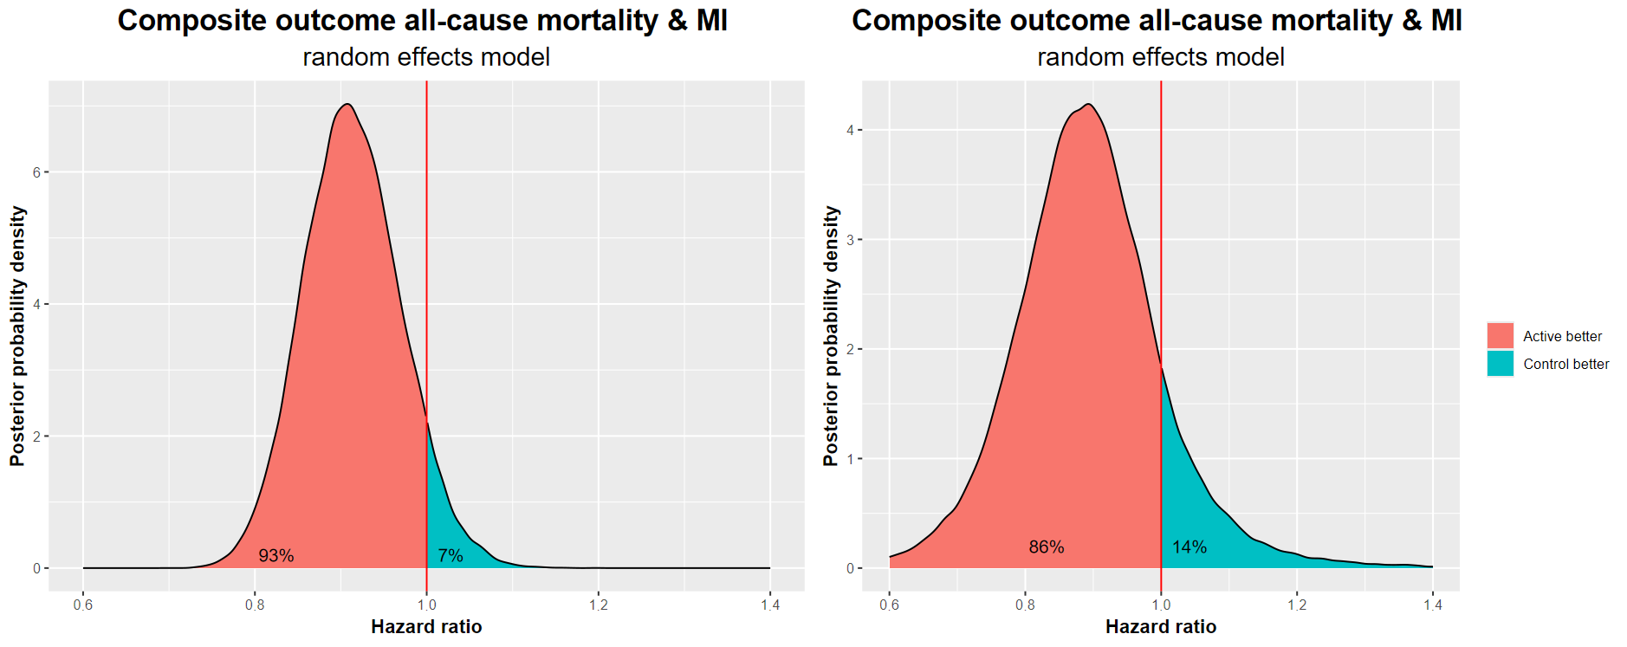

Finally, we create a figure summarizing the information on the treatment effect as estimated from 3 sources: 1) the IPD-MA result (i.e. including all studies except SENIOR_RITA) 2) the result from SENIOR_RITA; 3) the published result from the combined, random effects meta-analysis from all studies.

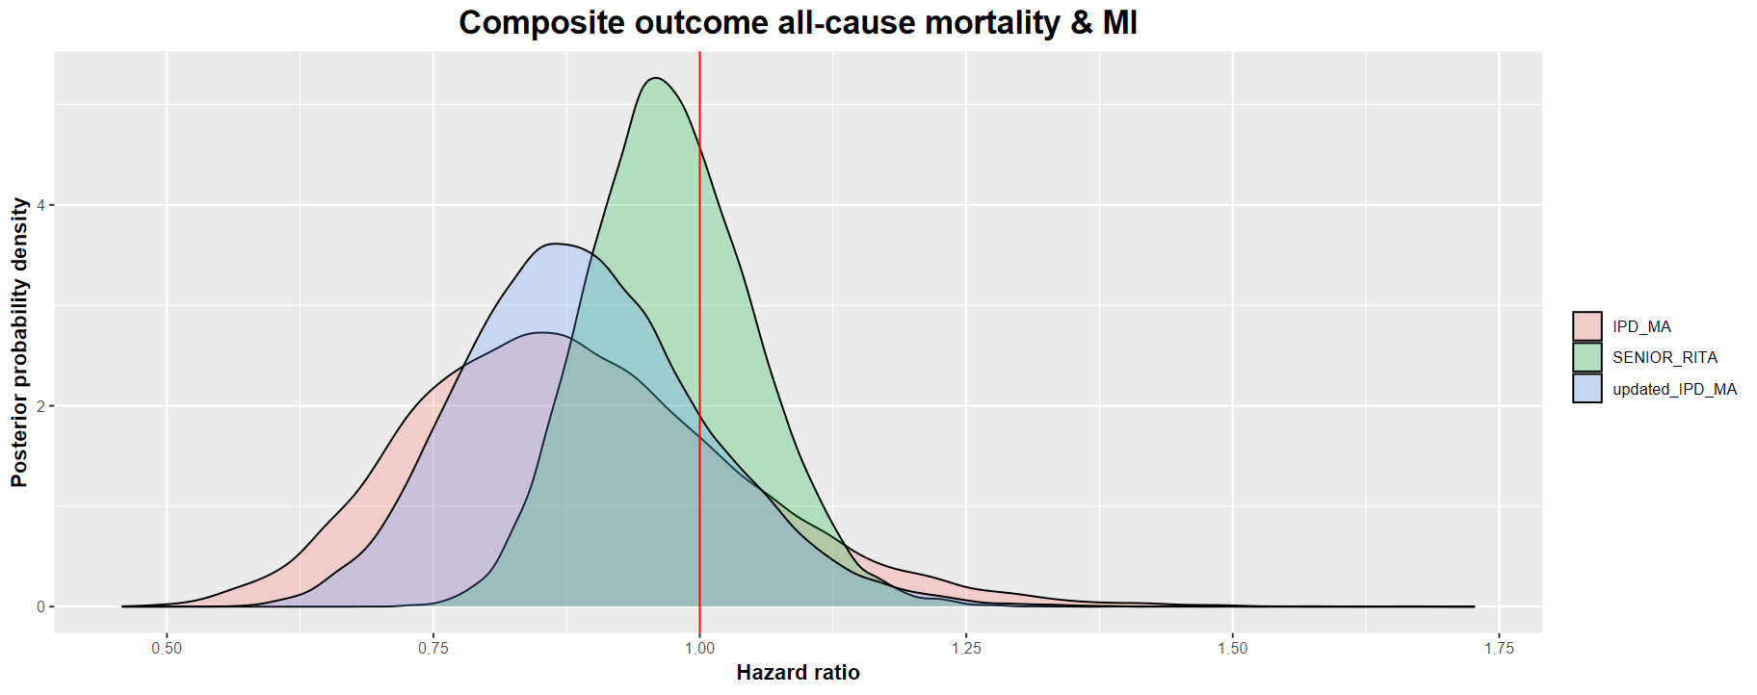

In sensitivity analyses we used a different prior for heterogeneity (a weakly informative half Cauchy distribution with center 0 and scale 2.5, recommended by Gellman et al.5) and a weakly informative prior for the treatment effect, . Results were not materially affected.

# All-cause mortality

For this outcome we were not able to extract information on the treatment effect from the individual studies. We thus jointly analysed the published results from the IPD meta-analysis1 and the SENIOR_RITA trial.2 Here is the data we used:

Study hr lci uci

10 IPD_META-ANALYSIS 1.03 0.69 1.53

17 SENIOR-RITA 1.13 0.95 1.34

## Frequentist meta-analysis

We first performed a meta-analysis of the two sources of evidence, using a fixed effect model.

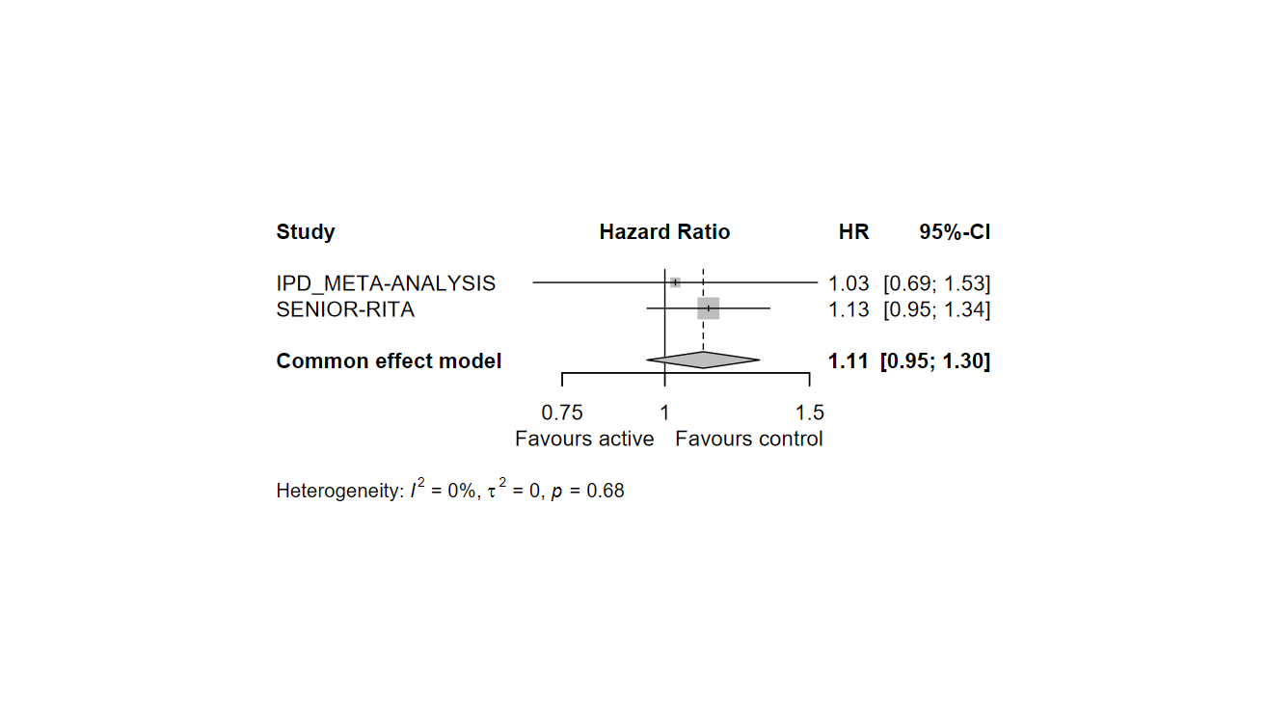

## Bayesian analysis

We analysed the data using the IPD results as prior distribution and update it using SENIOR-RITA results. The model is the following:

We followed the same fitting procedures as for the primary outcome (convergence was evident in results; metrics not shown).

The posterior estimate for HR was 1.11 [0.95; 1.30]. There was a 90.8% probability that HR>1.

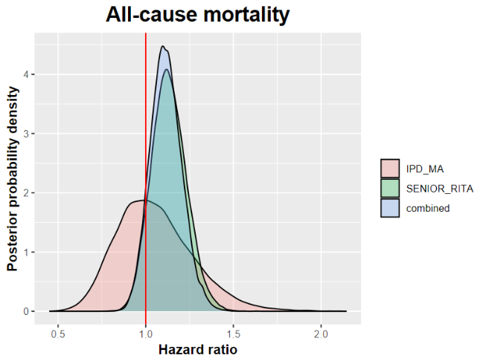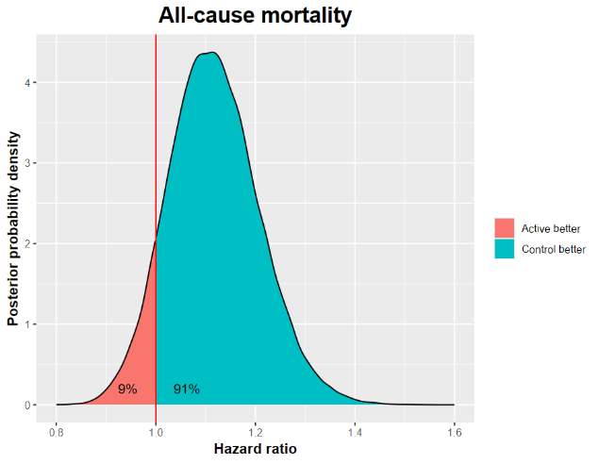

# Cardiovascular mortality

We repeated the same analyses as for all-cause mortality.

Study hr lci uci

19 IPD_META-ANALYSIS 0.89 0.57 1.40

26 SENIOR-RITA 1.11 0.86 1.44

## Frequentist meta-analysis

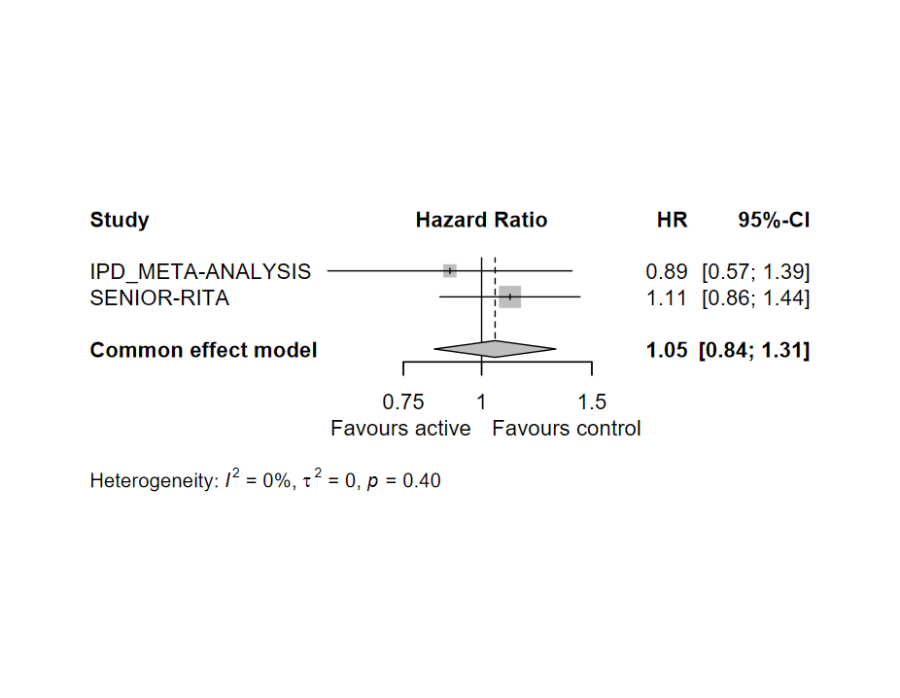

## Bayesian analysis

We use the IPD results as prior and update it using SENIOR-RITA results, as per the all-cause mortality outcome. We followed the same fitting procedures as for the primary outcome (convergence was evident in results; metrics not shown).

The posterior estimate for HR was 1.05 [0.84; 1.31]. There was a 66.6% probability that HR>1.

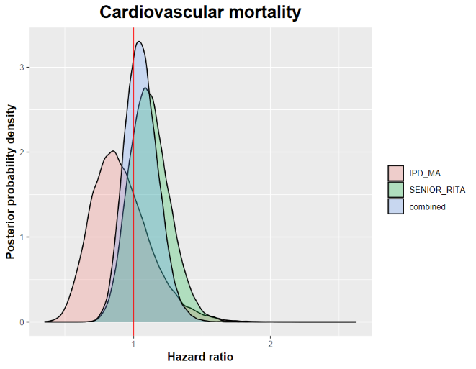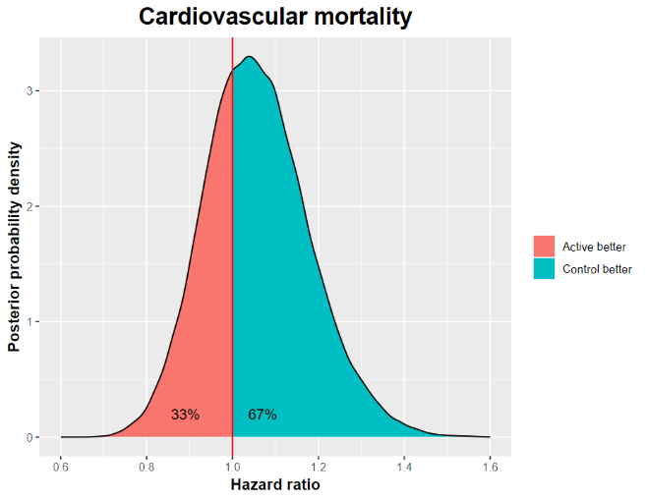

# Myocardial Infarction

We repeated the same analyses as for all-cause mortality.

Study hr lci uci

28 IPD_META-ANALYSIS 0.62 0.44 0.87

35 SENIOR-RITA 0.75 0.57 0.99

## Frequentist meta-analysis

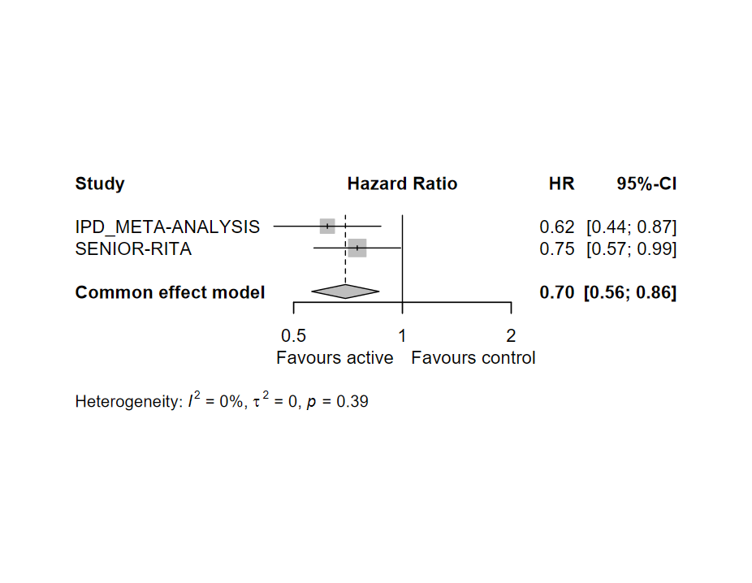

## Bayesian analysis

We use the IPD results as prior, and update it using SENIOR-RITA results.

The posterior estimate for HR was 0.70 [0.56; 0.86]. There was a 99.96% probability that HR<1.

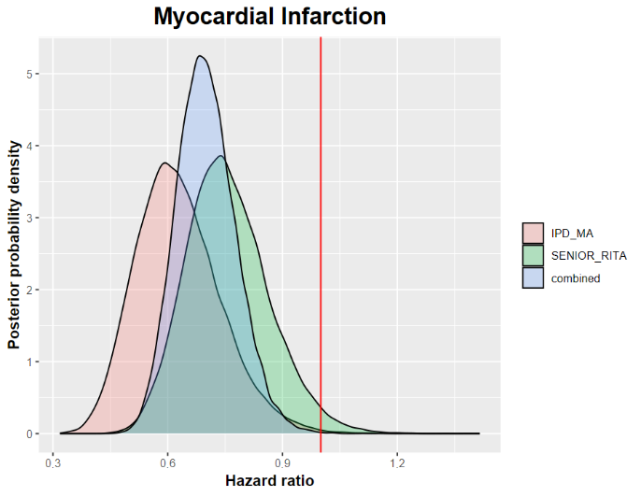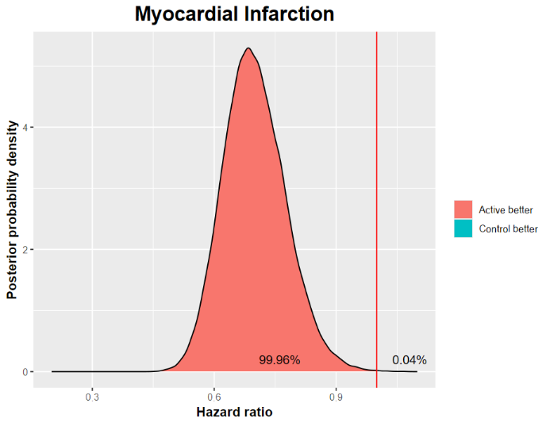

# Urgent revascularization

We repeated the same analyses as for all-cause mortality.

Study hr lci uci

37 IPD_META-ANALYSIS 0.41 0.18 0.95

44 SENIOR-RITA 0.26 0.17 0.39

## Frequentist meta-analysis

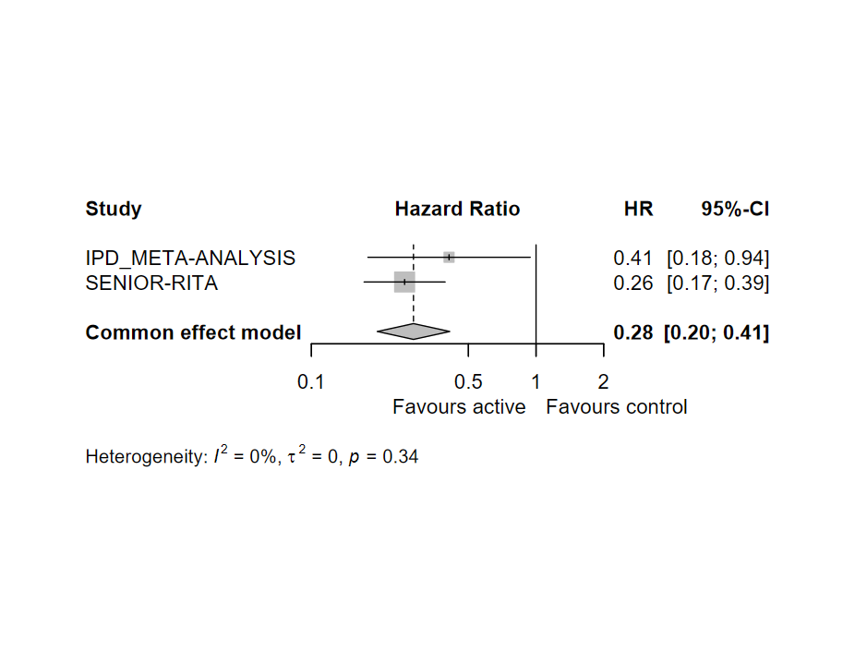

## Bayesian analysis

We use the IPD results as prior and update it using SENIOR-RITA results, as per the all-cause mortality outcome. We followed the same fitting procedures as for the primary outcome (convergence was evident in results; metrics not shown).

The posterior estimate for HR was 0.28 [0.20; 0.41]. There was a 100% probability that HR<1.

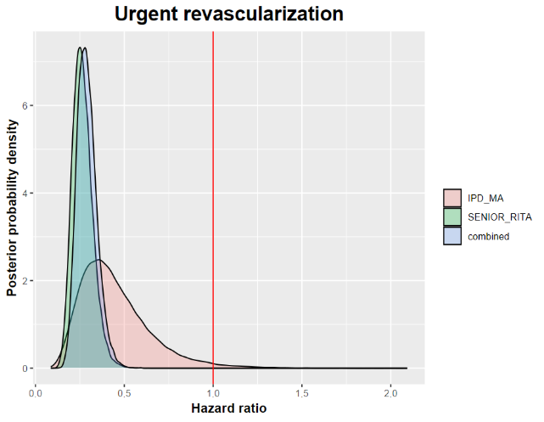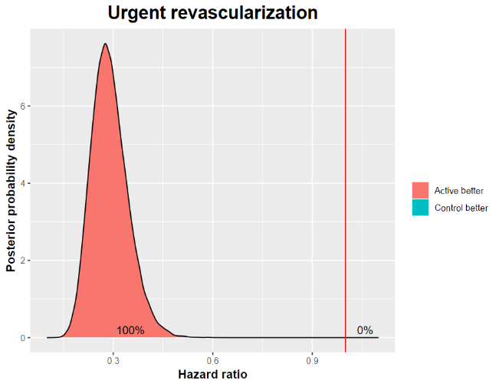

# Stroke

We repeated the same analyses as for all-cause mortality.

Study hr lci uci

46 IPD_META-ANALYSIS 1.46 0.74 2.89

53 SENIOR-RITA 0.81 0.51 1.28

## Frequentist meta-analysis

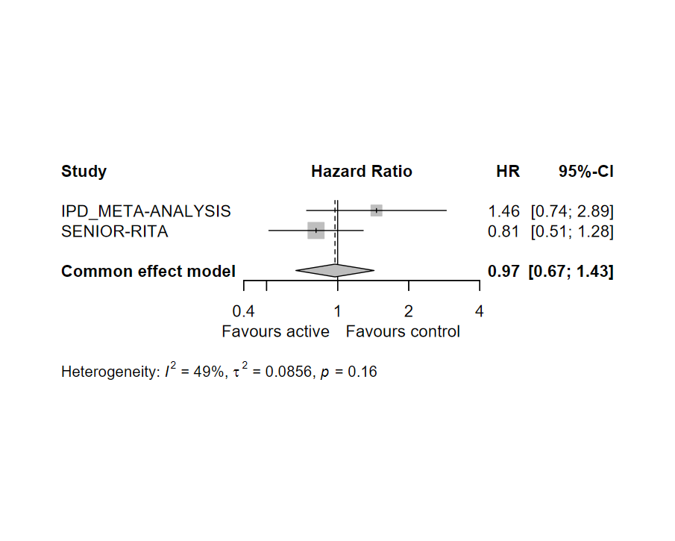

## Bayesian analysis

We use the IPD results as prior and update it using SENIOR-RITA results, as per the all-cause mortality outcome. We followed the same fitting procedures as for the primary outcome (convergence was evident in results; metrics not shown).

The posterior estimate for HR was 0.97 [0.67; 1,43]. There was a 45% probability that HR>1.

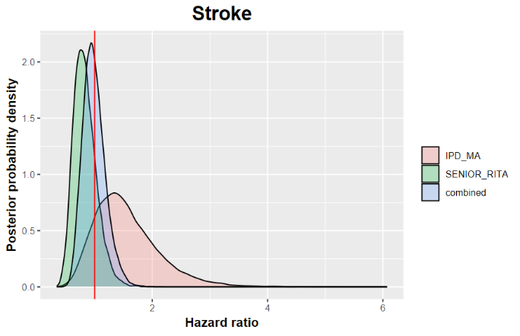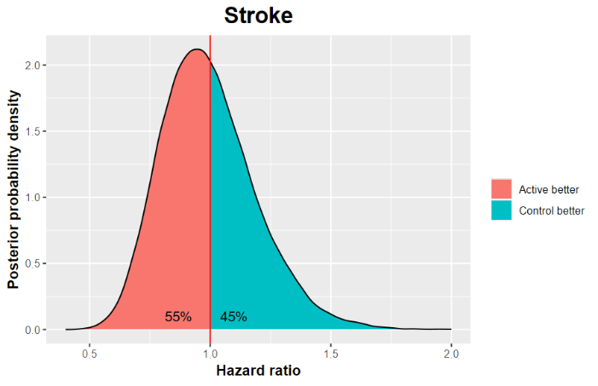

# Additional results

Aiming to enhance the utility and clinical relevance of our findings, below we show the posterior probabilities that the HR is lower or greater than a series of values. For the composite outcome, the estimation was made using the random effects meta-analysis model. HR<1 favors invasive treatments.

Posterior probabilities that the invasive treatment is **beneficial**:

|  |  |  |  |  |
| --- | --- | --- | --- | --- |
| **Outcome** | **P(HR<1)** | **P(HR<0.975)** | **P(HR<0.95)** | **P(HR<0.90)** |
| Composite outcome all cause mortality and MI | 86% | 81% | 73% | 54% |
| All-cause mortality | 9% | 5% | 2% | 0% |
| Cardiovascular mortality | 33% | 26% | 19% | 9% |
| MI | 100% | 100% | 100% | 99% |
| Urgent revascularization | 100% | 100% | 100% | 100% |
| Stroke | 55% | 50% | 45% | 34% |

**\*Smaller HRs correspond to larger benefit of invasive treatment**

Posterior probabilities that the invasive treatment is **detrimental**:

|  |  |  |  |  |
| --- | --- | --- | --- | --- |
| **Outcome** | **P(HR>1)** | **P(HR>1.025)** | **P(HR>1.05)** | **P(HR>1.10)** |
| Composite outcome all cause mortality and MI | 14% | 10% | 7% | 4% |
| All-cause mortality | 91% | 85% | 77% | 56% |
| Cardiovascular mortality | 67% | 59% | 50% | 34% |
| MI | 0% | 0% | 0% | 0% |
| Urgent revascularization | 0% | 0% | 0% | 0% |
| Stroke | 45% | 40% | 35% | 27% |

**\*Larger HRs correspond to larger harm of invasive treatment**

Explanation examples:

-there is 54% that invasive treatment reduces the hazard of the composite outcome by 10% or more i.e. probability of HR<0.90 is 0.54).

-there is 77% that invasive treatment increases the hazard of all-cause mortality by 5% or more (i.e. probability of HR>1.05 is 0.77).

# References

1. Kotanidis, C. P. *et al.* Invasive vs. conservative management of older patients with non-ST-elevation acute coronary syndrome: individual patient data meta-analysis. *Eur Heart J* **45**, 2052–2062 (2024).

2. Kunadian, V. *et al.* Invasive Treatment Strategy for Older Patients with Myocardial Infarction. *N Engl J Med* **391**, 1673–1684 (2024).

3. Balduzzi, S., Rücker, G. & Schwarzer, G. How to perform a meta-analysis with R: a practical tutorial. *Evid Based Ment Health* **22**, 153–160 (2019).

4. Su [aut, Y.-S., cre, Yajima, M. & Baio, G. R2jags: Using R to Run ‘JAGS’. (2024).

5. Gelman, A., Jakulin, A., Pittau, M. G. & Su, Y.-S. A weakly informative default prior distribution for logistic and other regression models. *Ann. Appl. Stat.* **2**, (2008).